palm controlled with rf camera
robot

Team members
- TARUN MIRANI
killerkid007@gmail.com
9096-895-222
- amit bhatia
amy.bluffmaster143@yahoo.com
8446-383-938
- chandan jaisinghani
cjaisinghani@rediff.com
9096-327-137
- monish gurbaxani
mgmoni18@gmail.com
7385-170-0007
Institute name:-
S.H.Mansukhani Institute Of Technology,ulhasnagar
Project overview
What we present here is an elementary robotic land rover that can be controlled remotely using primarily the RF mode. The RE remote control has the advantage of adequate range (up to 200 meters with proper antenna) besides being omni directional. On the other hand, an ER remote would function over a limited range of about 5metres and the remote transmitter has to be oriented towards the receiver module quite precisely. However, the cost involved in using RE modules is much higher than of IR components and as such, we have included the re placement alternative of RF modules with their IR counterparts for using the IR remote control.
The proposed land rover can move in forward, and reverse directions. You would also be able to steer it towards left and right directions. While being turned to left or right, the corresponding blinking LEDs would blink to indicate the direction of its turning. Similarly, during reverse movement, reversing LEDs would be lit. Front and rear bumpers are provided using long operating lever of micro switches to switch off the drive motors during any collision.
The decoder being used for the project has latched outputs and as such you do not have to keep the buttons on remote control pressed for more than a few milliseconds. This helps prolong the battery life for remote.
Features
- Direction sensor is used to find out hand movement so that robot can move in all fore direction
- Direction sensor generate two code for each direction and then these code is encoded at transmitter and then transmiited
- recevied code at ther receiver is decoed into bit pattern which given to Motor drver IC which control the motor and Robot can function
- Distance is upto 300mts
- Robot can be controlled with mouse , keyboard , Palm(hand) and voice
- interactive User Interface is designed in vb

transmitter
RF transmitter and RF receiver
The RF transmitter arid receiver modules marketed by Aplus India, Mumbai have been employed for RF remote control. The RF transmitter TX-433 is an AM/ASIC transmitter. Its features include:
1. 5V-12V single supply operation
2. On-off-keying (OOK)/amplitude shift keying (ASK) data format
3. Up to 9.6kbps data rate
4. +9dBm output power (about 200m range)
5. SAW-based architecture
6. For antenna, a 45cm wire is adequate.
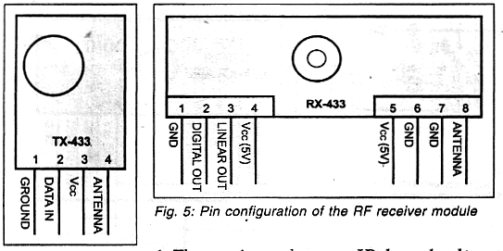

Receiver
RF receiver-decoder.
The complete RF receiver-decoder circuit employing HT12D is shown in Fig. 7. Assuming that identical address is selected on the encoder and the decoder, when any of the switches on the transmitter (marked as FWD, REV, RIGHT, LEFT) is depressed, the corresponding datapin of the demodulator will go low. The data outputs of HT12I) are fed to 8-bit priority encoder CD4532 via inverters to generate appropriate logic outputs in conformity with Table III to control the left-/right motors for required motion of the land rover as explained earlier.However, when STOP button is pressed on the remote transmitter, all data pins (D8 through D11 on the decoder will latch to the high output state. After inversion by NAND gates N1 through N4, all the outputs will be low and hence EI (pin 5) of CD4532 will go low to force all its outputs to go low. As a result, both the motors will stop running.

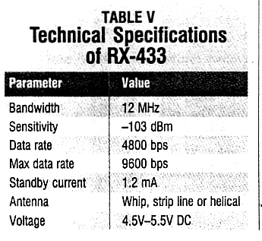
IR based alternative.

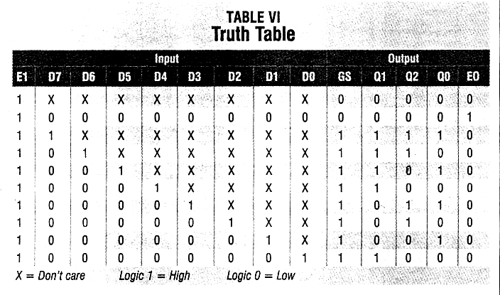

Thank you

